**EGERTON**  **UNIVERSITY**

**ONLINE LIBRARY SYSTEM PROJECT**

**USER MANUAL**

**S13/02367/19**

**MOURICE ADERO**

**Table of content**

Table of Contents

**Chapter 1** 1

**System Overview** 1

**Introduction to Online Library System** 1

**Purpose of this document** 1

**System Architecture** 1

**User Roles and Responsibilities** 2

**Login and Logout Process** 3

**Chapter 2** 4

**System Requirements** 4

**Hardware Requirements** 4

**Software Requirements** 4

**User Account Registration Process** 5

**Chapter 3** 6

**System Features** 6

**Homepage and Navigation** 6

**Searching for Books and Resources** 6

**Managing User Account Information** 7

**Accessing Google Books** 8

**Requesting for Items** 8

**Chapter 4** 9

**System Support** 9

**Troubleshooting Common Issues** 9

**System Maintenance and Upgrade** 10

**Glossary** 11

**List of Figures**

Figure 1: Login 3

Figure 2: Logout 3

Figure 3: User Registration 5

Figure 4: Search 6

Figure 5: Navigation Bar 6

Figure 6: Manage Account 7

# **Chapter 1**

## **System Overview**

### **Introduction to Online Library System**

The Online Library System is a web-based application that allows users to access digital books, journals, articles, and other related resources from anywhere at any time. The system provides access to a vast collection of e-resources, making it easier for students, readers, and researchers to access information for their academic and research needs.

The system is designed to provide a user-friendly interface that allows users to search for and access digital resources with ease. The system is accessible through any device with an internet connection, including laptops, tablets, and smartphones.

The system is designed to provide users with a personalized experience based on their field of interest.

The Online Library System is designed to be easy to use, reliable, and accessible to all users. This user manual provides a detailed guide on how to use the system to access digital resources and take advantage of all its features.

### **Purpose of this document**

The purpose of this user manual is to provide a comprehensive guide on how to use the Online Library System. It is intended for all users who will be using the system for their academic and research needs plus other lovers of books who likes reading for pleasure. The manual provides step-by-step instructions on how to perform various tasks in the system, including user registration, book search, requesting items, and other related activities. It will also provide an overview of the system's requirements, features, and support services available to users. The user manual aims to enhance the user experience by providing clear instructions and guidelines for the effective use of the system.

### **System Architecture**

The online library system has a client-server architecture. The server hosts the web application and the database, while the client communicates with the server using a web browser. The system is built using a three-tier architecture, which consists of a presentation layer, an application layer, and a data storage layer.

The presentation layer is responsible for presenting the user interface to the user. It is implemented using HTML, CSS, and JavaScript, through use of Bootstrap 5 and is rendered by the user's web browser.

The application layer is responsible for processing user requests and generating responses. It is implemented using server-side scripting languages which is PHP.

The data storage layer is responsible for storing and retrieving data from the system's database. It is implemented using a database management system of MySQL.

The system's architecture is designed to be scalable and extensible, allowing for future expansion and modification as needed. The use of a three-tier architecture also helps to ensure that the system is secure and robust, with each layer providing a distinct set of functions and protections.

### **User Roles and Responsibilities**

The Online Library System is designed to serve different types of users with different roles and responsibilities. The following are the user roles and their corresponding responsibilities:

**System Users:** These are the users of the system who consume the services offered by the system. They have the following responsibilities:

* Creating an account with the system by providing their information
* Browsing and searching the website to find books and items of interest
* Requesting books and other items they are interested in.

**Administrator:** The administrator is responsible for managing user accounts and permissions. They have the following responsibilities:

* Adding and updating books, authors, publishers, and other related information to the system
* Managing and accepting item requests
* Running reports to track the library's inventory and usage
* Ensuring that the system is up-to-date and functioning properly
* Creating and deleting user accounts
* Assigning user roles and permissions
* Monitoring system usage and generating reports
* Troubleshooting user issues and system errors

### **Login and Logout Process**

To access the features of the Online Library System, users are required to login using their registered credentials. The login process ensures that only authorized users can access the system. The following steps describe the login process:

* The user navigates to the login page and enters their registered email and password.
* The system validates the user's credentials against the database.
* If the credentials are correct, the system grants access to the user.
* If the credentials are incorrect, the system displays an error message and prompts the user to enter their credentials again.

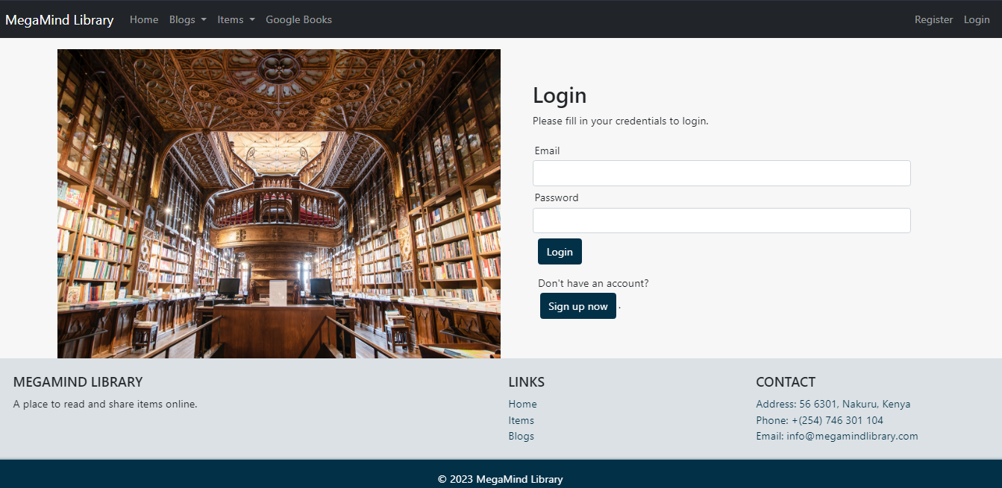

Figure 1: Login

Once the user has finished using the system, they can log out to prevent unauthorized access to their account. The following steps describe the logout process:

* The user clicks on the logout button located at the top right corner of the system interface.
* The system prompts the user to confirm that they want to log out.
* If the user confirms, the system logs them out and redirects them to the login page.
* If the user cancels the logout, they remain logged in to the system.



Figure 2: Logout

# **Chapter 2**

## **System Requirements**

### **Hardware Requirements**

* Computer: The system requires a computer with a minimum of GB of RAM and a dual-core processor. The system can run on both Windows and Mac OS.
* Internet Connection: The system requires a stable internet connection to access the online library resources. A minimum speed of 3 Mbps is recommended.
* Mobile Device: The system can also be accessed through a mobile device, such as a smartphone or tablet. The mobile device should have a minimum screen size of 5 inches and an internet connection.

### **Software Requirements**

To access the Online Library System, the following software must be installed on your computer:

Web browser: The Online Library System is accessed through a web browser. The system supports the following browsers:

Google Chrome (latest version)

Mozilla Firefox (latest version)

Microsoft Edge (latest version)

Safari (latest version)

Operating System: The Online Library System is compatible with the following operating systems:

Windows 10

MacOS

Linux

### **User Account Registration Process**

In order to use the online library system, users must first register for an account. The user account registration process is designed to be simple and intuitive, while also ensuring the security of user information.

The following are the steps required to register for an account:

* Click on the "Register" button on the login page of the online library system.
* Enter the required personal information, including name, email address, and a password. The system will automatically check the validity of the email address and password entered by the user.
* The user can then log in to the online library system using their email address and password.
* During the registration process, users will also be asked to provide additional information, such as field of interest. This information helps on giving personalised experience to the user.

It's important to note that user account information is stored securely and is not shared with third parties. Users can also update their account information at any time by logging in to the online library system and accessing their account profile settings.

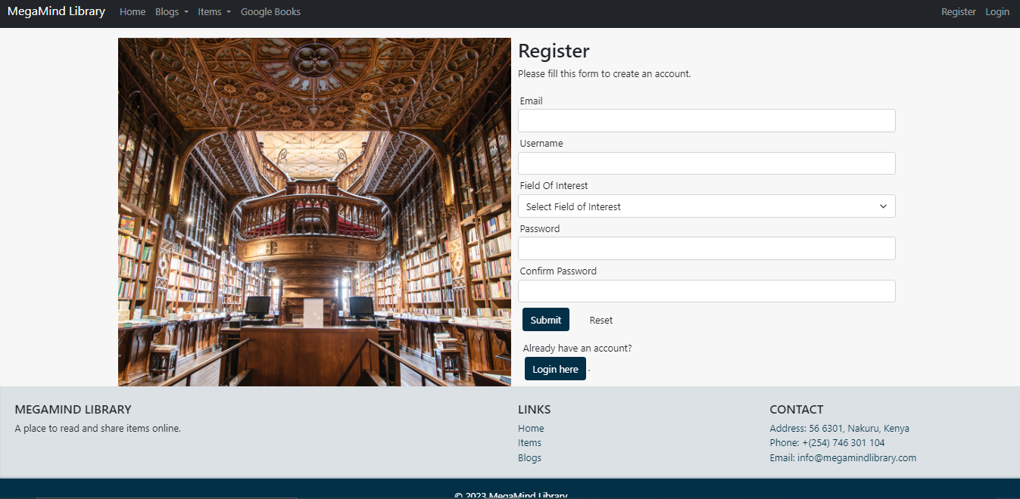

Figure 3: User Registration

# **Chapter 3**

## **System Features**

### **Homepage and Navigation**

The Online Library System provides an intuitive and user-friendly homepage and navigation that allows users to easily search for and access the library’s resources. The homepage is the first page that users see when they log in to the system, and it serves as a hub for all major functions and features.

The homepage is designed to provide quick access to the following key functions:

Search Bar: Users can search for books, authors, or other materials by entering relevant keywords into the search bar. The system will then display a list of search results that match the user’s query.



Figure 4: Search

Top Books: The homepage also displays a list of featured books, which are from the most recent uploads.

Navigation Menu: The navigation menu provides quick links to various parts of the system, including user account settings, request materials, and google books.



Figure 5: Navigation Bar

Navigation within the system is designed to be intuitive and user-friendly. Users can easily navigate to different parts of the system by clicking on links or buttons within the interface. The navigation menu provides a clear and organized overview of the various sections of the system, allowing users to easily find what they are looking for.

### **Searching for Books and Resources**

Searching for books and resources is a key feature of the online library system. It allows users to search for books, journals, articles, and other resources by author, title, subject, or keyword. The following are the details of this feature:

* Search Bar: The search bar is prominently displayed on the homepage of the system, allowing users to easily find it. The search bar is simple to use and intuitive, allowing users to enter their search terms easily.
* Filters: The system provides various search filters to help users narrow down their search results. Users can filter their search results by book title, author, subject, and publication date.
* Search Results: Once the user enters their search terms, the system displays the search results. The search results provide details about the resources, such as the title, author, publication date, and format.
* Resource Preview: Users can preview the resources before selecting them. The preview provides information about the resource's contents, including a brief summary, author, and publisher.

### **Managing User Account Information**

This feature allows users to manage their account information, such as updating their personal details and changing their password. The following functionalities are included under this feature:

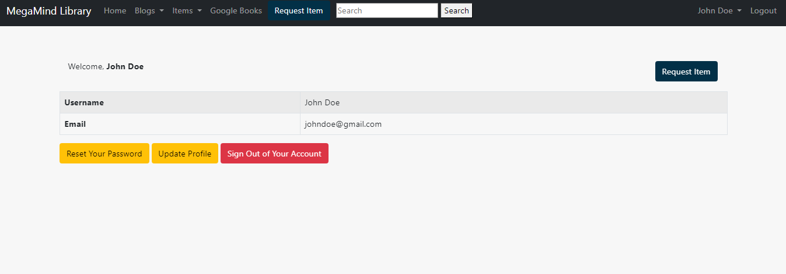

Figure 6: Manage Account

Update Personal Information: Users can update their personal information, such as their name, email address, phone number, and address, in the system. This information can be accessed and modified by the user from the ‘Profile’ under username section on the homepage.

Change Password: Users can change their password by clicking on the ‘Change Password’ option on the ‘Profile’ page. The system will verify that the new password meets the password requirements and then update the user's password.

Request an Item: If a user wishes to request an item like a book, they can make a request through the ‘Request Item’ tab in the navigation. The requests are shown in the notifications sections in the user profile. The user can then view the responses from the administrators and also view the requested material directly.

### **Accessing Google Books**

The Online Library System allows users to access online resources such as Google Books. This feature enables users to search for books and other resources that are not available in the library’s physical collection. To access online resources, the user needs to have an internet connection and a valid library account.

Once the user has logged in to the Online Library System, they can navigate to the Google Books page to find the book or resource they want to access. The user can then search for the required book. The user gets a view button that enables them to view the google book through a third-party interface. The Online Library System does not provide access to online resources that require a subscription or payment. If the user attempts to access a resource that requires a subscription or payment, they will be redirected to the provider’s website where they can subscribe or purchase the resource.

### **Requesting for Items**

The online library system provides users with the ability to request items and resources that are not available in the library's collection. Users can place a request for books, articles, and other resources by filling out an online request form available on the request item page.

The request form requires users to provide information about the requested item, such as the title, author, publisher, and publication date. User can also give a title for the requested item as a request title.

Once the request is submitted, it is sent to the administrator for review. The admin will then check the availability of the requested item and take necessary actions to acquire it. This may involve purchasing the item or getting it from another library.

Users can track the status of their requests through the requests table in the ‘request item’ page.

The requests can also be in form of a suggestion and the system admins can respond to them appropriately.

# **Chapter 4**

## **System Support**

### **Troubleshooting Common Issues**

**Problem: Unable to log in to the system Solution:**

* Check that you are entering the correct username and password. Passwords are case sensitive, so make sure you are using the correct case.
* Make sure that you have an active internet connection.
* Clear your browser cache and cookies, and try logging in again.

**Problem: Unable to access Google Books Solution:**

* Check that you have entered the correct login credentials if required.
* Make sure that you have an active internet connection.
* If you are accessing the online resources from a public computer or network, check that the computer or network allows access to the resources.
* Clear your browser cache and cookies, and try accessing the resources again.
* If you are still unable to access the resources, contact the system administrator for assistance.

**Problem: Unable to view book or article Solution:**

* Check that you have entered the correct book or article title.
* If you are accessing the book or article from a public computer or network, check that the computer or network allows access to the book or article.
* Make sure that you have an active internet connection.
* Clear your browser cache and cookies, and try accessing the book or article again.
* If you are still unable to view the book or article, contact the system administrator for assistance.

**Problem: Unable to update user account information Solution:**

* Check that you are entering the correct information in the required fields.
* Make sure that you have an active internet connection.
* Clear your browser cache and cookies, and try updating your account information again.
* If you are still unable to update your account information, contact the system administrator for assistance.

**Problem: Error message displayed Solution:**

* Read the error message carefully and try to understand what the problem is.
* Take note of the error message and contact the system administrator for assistance.

### **System Maintenance and Upgrade**

This section provides information on how to maintain and upgrade the Online Library System to ensure its continued smooth operation.

Maintenance: Regular maintenance of the system is essential to ensure its smooth functioning. The following maintenance activities should be performed regularly:

* Backups: Back up the database and system files regularly to ensure that data is not lost in the event of a system failure.
* Server Maintenance: Regularly maintain the server to ensure that the system is up-to-date, secure and reliable.
* Bug Fixes: Regularly check the system for any bugs or issues and fix them promptly to prevent further issues.
* Security: Regularly check the system for any security vulnerabilities and take measures to address them to prevent any potential security breaches.
* Upgrade: Periodically, the system may need to be upgraded to add new features, fix bugs or address security vulnerabilities. The following upgrade process should be followed:
* Back up the system and database before proceeding with the upgrade.
* Download the latest version of the system software and follow the instructions provided by the software vendor.
* Test the upgraded system to ensure that it is working properly.
* Once the upgrade has been completed, verify that all data and configurations are intact and functioning as expected.
* Inform all system users of any new features, changes or known issues resulting from the upgrade.

It is recommended that the system administrator document all maintenance and upgrade activities for future reference.

# **Glossary**

To help you better understand the terminology used in this User Manual, here is a glossary of key terms and definitions:

**Online Library System:** An internet-based platform that allows users to search, access, and manage digital resources such as books, journals, and articles.

**User Account:** A user profile that contains personal information, login credentials, and account settings. Users can create an account to access the library system’s services and resources.

**Search Bar:** A text field where users can enter keywords, titles, authors, and other search terms to find relevant resources in the library system.

**Resource:** A digital item that can be accessed and downloaded from the library system. Examples of resources include books, journals, articles, and videos.

**Request:** A feature that allows users to reserve, borrow, or request digital resources from the library system.

**Notification:** A message or alert that informs users of system events such as account updates, overdue resources, and system maintenance.

**Browser:** A software application used to access and view web pages on the internet. Examples of browsers include Google Chrome, Mozilla Firefox, and Microsoft Edge.

**Login Credentials:** A username and password that are required to access a user account in the library system.

**Upgrade:** A process of improving or enhancing the library system’s functionality, performance, or security. Upgrades may involve software updates, hardware improvements, or system configuration changes.

**Maintenance:** A process of keeping the library system in good working condition by performing regular checks, updates, and repairs. Maintenance tasks may include system backups, security patches, and hardware replacements.

We hope that this glossary helps you understand the key terms and concepts used in this User Manual. If you have any questions or need further assistance, please contact our support team through [megamind@library.co.ke](mailto:megamind@library.co.ke).